MACHINE LEARNING–BASED INTERACTIVE MOBILE APPLICATION FOR EARLY RISK DETECTION AND MIDWIFERY SUPPORT

Kumarage M.B.S.I.E
(IT22606556)

Dissertation submitted in partial fulfillment of the requirements for the Bachelor of Science (Honours) in Information Technology Specializing in Interactive Media

Department of Information Technology
Sri Lanka Institute of Information Technology
Sri Lanka

June 2025

DECLARATION
I declare that this is my own work and this dissertation does not incorporate without acknowledgement any material previously submitted for a Degree or Diploma in any other University or institute of higher learning and to the best of my knowledge and belief it does not contain any material previously published or written by another person except where the acknowledgement is made in the text.

Also, I hereby grant to Sri Lanka Institute of Information Technology, the non-exclusive right to reproduce and distribute my dissertation, in whole or in part in print, electronic or other medium. I retain the right to use this content in whole or in part in future works (such as articles or books).

Signature: ________________________ Date: ________________

The above candidate has carried out research for the Bachelor's Degree Dissertation under my supervision.

Signature of Supervisor: _______________ Date: ________________

Mr. Didula Thanaweera Arachchi
Department of Information Technology, SLIIT

ABSTRACT
This research proposes the design and development of an interactive mobile application that supports Sri Lankan midwives in antenatal care through real-time machine learning–based maternal risk prediction, interactive data visualization, and multimodal alerts. The system integrates maternal vital data such as blood pressure, blood sugar, fetal heart rate, and hemoglobin levels to predict early risk conditions including anemia and pregnancy-related complications.
Unlike existing maternal health applications that are either mother-focused or guideline-only tools, the proposed system is specifically designed for midwives and midwifery students. It provides real-time dashboards, explainable machine learning outputs, and voice and haptic feedback to improve decision-making speed, accuracy, and confidence. The application is culturally adapted with Sinhala, Tamil, and English language support and is optimized for low- and mid-range mobile devices commonly used in Sri Lanka.

Keywords: mHealth; machine learning; maternal risk prediction; midwifery; mobile application; TensorFlow Lite; data visualization; antenatal care; Sri Lanka; SHAP

ACKNOWLEDGEMENT
I would like to express my sincere gratitude to my dissertation supervisor Mr. Didula Thanaweera Arachchi and co-supervisor Mrs. Narmada Gamage from the Department of Information Technology, Sri Lanka Institute of Information Technology, for their invaluable guidance, constructive feedback, and continuous encouragement throughout this research.
I also extend my heartfelt thanks to our external supervisor, a senior midwife with over 26 years of field experience, whose practical insights into antenatal care challenges in Sri Lanka were indispensable in shaping the application's features to address real-world midwifery needs.
I am grateful to the Humanities and Nursing Departments of SLIIT for providing access to medical references, maternal health guidelines, and laboratory facilities. Special thanks to the 15–20 midwifery and nursing students who participated in the testing phase, whose feedback was crucial to improving the system.
Finally, I wish to thank my family and friends for their unwavering support throughout this journey.

TABLE OF CONTENTS
Declaration i
Abstract ii
Acknowledgement iii
Table of Contents iv
List of Tables v
List of Figures vi
List of Abbreviations vii

1. Introduction 1
1.1 Background and Literature Survey 1
1.2 Research Gap 3
1.3 Research Problem 5
1.4 Research Objectives 5

2. Methodology 7
2.1 Overview of the Methodology 7
2.2 Mobile Application Development 9
2.3 Data Analysis and Dashboard Design 10
2.4 Technologies Used 11

3. Results and Discussion 13
3.1 Functional Requirements Evaluation 13
3.2 Non-Functional Requirements Evaluation 14
3.3 System Performance Metrics 15
3.4 Research Findings 16
3.5 Discussion 17

4. Conclusion 19
4.1 Summary of Contributions 19
4.2 Limitations 20
4.3 Future Work 20

Reference List 22
Appendices 25

LIST OF TABLES

Table 1.1 Research Gap Analysis 4
Table 1.2 System Gap Comparison 5
Table 2.1 Technologies Used 12
Table 3.1 Functional Requirements Evaluation 13
Table 3.2 Non-Functional Requirements Evaluation 14
Table 3.3 ML Model Performance Metrics 15
Table 4.1 Project Budget 24

LIST OF FIGURES

Figure 1.1 Antenatal care phase – midwifery support activities 2
Figure 1.2 Antenatal monitoring parameters – normal ranges and high-risk thresholds 3
Figure 2.1 Individual system architecture diagram 8
Figure 3.1 ML model performance metrics 15
Figure 3.2 Voice and haptic alert workflow 16

LIST OF ABBREVIATIONS

Abbreviation | Description
ANC | Antenatal Care
API | Application Programming Interface
BP | Blood Pressure
DB | Database
FHB | Family Health Bureau (Sri Lanka)
FHR | Fetal Heart Rate
LIME | Local Interpretable Model-Agnostic Explanations
mHealth | Mobile Health
ML | Machine Learning
MOH | Ministry of Health (Sri Lanka)
PPH | Postpartum Hemorrhage
SHAP | SHapley Additive exPlanations
SQL | Structured Query Language
SUS | System Usability Scale
SVM | Support Vector Machine
UI | User Interface
UX | User Experience
WHO | World Health Organization

CHAPTER 1: INTRODUCTION
1.1 Background and Literature Survey
Midwives play a critical role in Sri Lanka's maternal healthcare system, particularly in antenatal monitoring and early detection of pregnancy-related risks. Although Sri Lanka has achieved significant reductions in maternal mortality, preventable complications such as anemia, hypertension, and delayed emergency response remain persistent challenges, especially in rural and semi-urban settings where access to specialist care is limited.
With the increasing availability of digital health data and smartphone penetration across Sri Lanka, there is a substantial opportunity to enhance midwives' clinical decision-making using intelligent mobile tools. However, most existing research on maternal risk prediction using machine learning remains confined to academic prototype models that lack real-time mobile deployment or integration into everyday midwifery workflows. This dissertation responds to that gap by proposing and evaluating a machine learning–based interactive mobile application that delivers real-time risk predictions, intuitive data visualizations, and actionable multimodal alerts directly to midwives.
Recent studies demonstrate the effectiveness of machine learning models such as Random Forest, Support Vector Machines (SVM), XGBoost, and deep learning architectures in predicting maternal health risks with accuracies exceeding 85 percent. Research by Assaduzzaman et al. [1] and Harnal et al. [2] highlights improved predictive performance through advanced cross-validation techniques, while Uma Maheswari et al. [3] emphasizes the importance of handling class imbalance using SMOTE and improving model interpretability using SHAP.
In Sri Lanka, midwives operate primarily under the supervision of the Family Health Bureau (FHB) and the Ministry of Health (MOH), managing antenatal clinic visits and home-based monitoring. Key parameters monitored during antenatal care include systolic and diastolic blood pressure, blood sugar, fetal heart rate, hemoglobin, and maternal body temperature. Delays or errors in interpreting these parameters, particularly in resource-constrained settings, directly contribute to preventable maternal and neonatal morbidity.

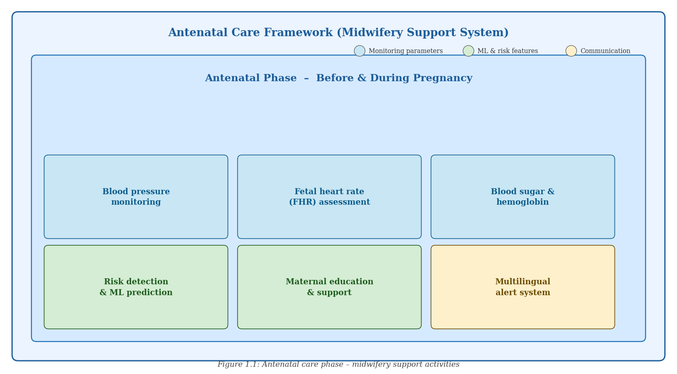
Figure 1.1: Antenatal care phase – midwifery support activities
1.2 Research Gap
A systematic review of existing maternal health applications and machine learning models reveals the following critical gaps:
- Lack of midwife-focused mobile applications that integrate ML predictions into clinical workflows.
- Absence of real-time interactive data visualization for monitoring maternal health trends during antenatal visits.
- No existing system incorporates voice or haptic feedback specifically designed for urgent maternal health alerts in low-connectivity environments.
- Limited cultural and language adaptation for Sri Lankan users — trilingual support (Sinhala, Tamil, English) is absent in all reviewed systems.
- Minimal usability testing and clinical simulation evaluation with actual midwives or midwifery students.

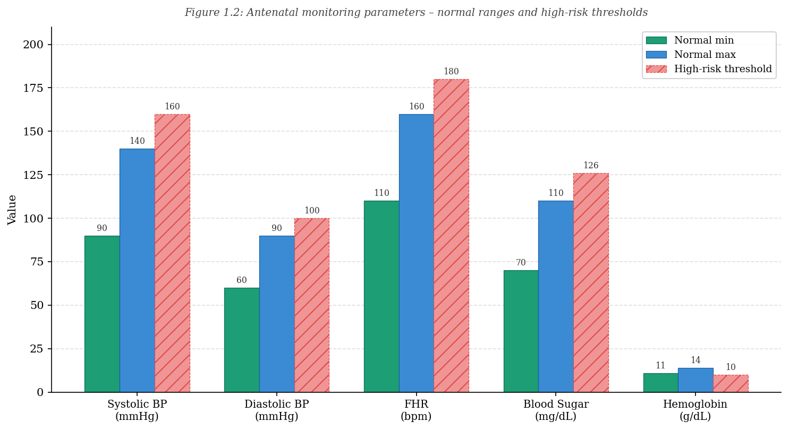
Figure 1.2: Antenatal monitoring parameters – normal ranges and high-risk thresholds
Table 1.1 maps these gaps against the five most relevant prior studies reviewed in the literature.

Research Paper | Discussion | Research Gap
Assaduzzaman et al. (2023) | Built ML classifiers (SVM, Random Forest) achieving ~89% accuracy for early maternal risk prediction. | Not integrated into a midwife-focused mobile app; no real-time interface.
Harnal et al. (2025) | Compared percentage split vs. k-fold cross-validation; k-fold improved accuracy by ~5%. | Lacked interactive explainability or deployment in clinical settings.
Uma Maheswari et al. (2024) | Applied SMOTE and SHAP with XGBoost; recall improved by 12%. | No live dashboards or clinical workflow integration; explainability only post-hoc.
Rahman & Alam (2023) | CNN/LSTM models with LIME; achieved 91% F1-score. | High computational load; no real-time on-device inference or haptic alerts.
Ravi et al. (2022) | Analyzed time-series trajectories of maternal risk factors over pregnancy. | No mobile deployment; no midwife-centered design or user interface.
Table 1.1: Research gap analysis

Table 1.2 provides a comparative feature matrix showing that the proposed system uniquely addresses all identified gaps simultaneously.

Feature | Proposed | Assaduzzaman | Harnal | Uma Mah. | Ravi
Uses machine learning | Yes | Yes | Yes | Yes | Yes
Includes data visualization | Yes | No | No | No | No
Focused on midwives | Yes | No | No | No | No
Real-time risk detection | Yes | Yes | Yes | Yes | Yes
Voice & haptic feedback | Yes | No | No | No | No
Multilingual support | Yes | No | No | No | No
Prototype tested with users | Yes | Yes | No | No | No
Table 1.2: System gap comparison
1.3 Research Problem
Midwives in Sri Lanka lack access to intelligent, real-time digital tools that can transform maternal health data into actionable clinical insights during antenatal care consultations.

Problem Statement:
How effective is an interactive mobile application with embedded machine learning and data visualization capabilities in improving midwives' decision-making accuracy and response time during antenatal maternal risk assessment?
1.4 Research Objectives
The main objective of this research is to develop and evaluate a machine learning–based interactive mobile application that improves antenatal risk detection and clinical decision-making among midwives in Sri Lanka.

The specific objectives are:
- To design and integrate lightweight supervised machine learning models for real-time maternal risk prediction, including models for anemia detection, blood pressure risk classification, and blood sugar abnormality detection.
- To develop interactive dashboards to visualize maternal health trends and risk levels, including time-series charts for blood pressure, fetal heart rate, and hemoglobin over the course of pregnancy.
- To implement voice and haptic alerts to support rapid clinical response when abnormal vital parameters are detected.
- To ensure cultural relevance through a multilingual (Sinhala, Tamil, and English) user interface design appropriate for the Sri Lankan antenatal care context.
- To evaluate system usability, predictive accuracy, and decision impact through midwife testing using the System Usability Scale (SUS) and clinical simulation trials.

CHAPTER 2: METHODOLOGY
2.1 Overview of the Methodology
This research follows a mixed-method development and evaluation approach that integrates software engineering practices, applied machine learning, and user-centered design principles. The methodology is structured across six sequential phases.

Phase 1 – Requirement Gathering:
Primary data collection was conducted through semi-structured interviews with practicing midwives and a review of FHB antenatal care guidelines. Key functional and non-functional requirements were identified, including the need for offline capability, multilingual support, and inference latency constraints.
Phase 2 – Data Collection and Preprocessing:
Anonymized maternal health datasets were sourced from publicly available repositories and local clinic records. Data preprocessing involved handling missing values, normalizing feature scales, and addressing class imbalance using SMOTE (Synthetic Minority Over-sampling Technique) to ensure unbiased model training across risk categories.
Phase 3 – Machine Learning Model Development:
Supervised ML models were trained and evaluated, including Random Forest, SVM, XGBoost, and a CNN/LSTM architecture for time-series risk patterns. Models were converted to TensorFlow Lite format for efficient on-device inference. SHAP and LIME were integrated to provide explainable AI outputs alongside risk predictions.
Phase 4 – Mobile Application Development:
A cross-platform mobile application was implemented using Flutter. The application features an interactive UI for maternal antenatal monitoring, voice and haptic alert integration, and offline data entry with Firebase/MySQL synchronization. The UI was designed in Figma and implemented with full Sinhala, Tamil, and English language support.
Phase 5 – Explainability and Visualization:
SHAP/LIME integration provides midwives with human-interpretable explanations of risk predictions, identifying the most influential vital parameters for each alert. Interactive Chart.js dashboards visualize blood pressure trends, fetal heart rate patterns, and hemoglobin levels over the antenatal period.
Phase 6 – Testing and Validation:
System usability was evaluated using the System Usability Scale (SUS) with 15–20 midwifery and nursing students. Clinical simulation trials assessed the impact of the application on decision-making speed and accuracy. ML model performance was evaluated using accuracy, precision, recall, F1-score, and AUC-ROC metrics.

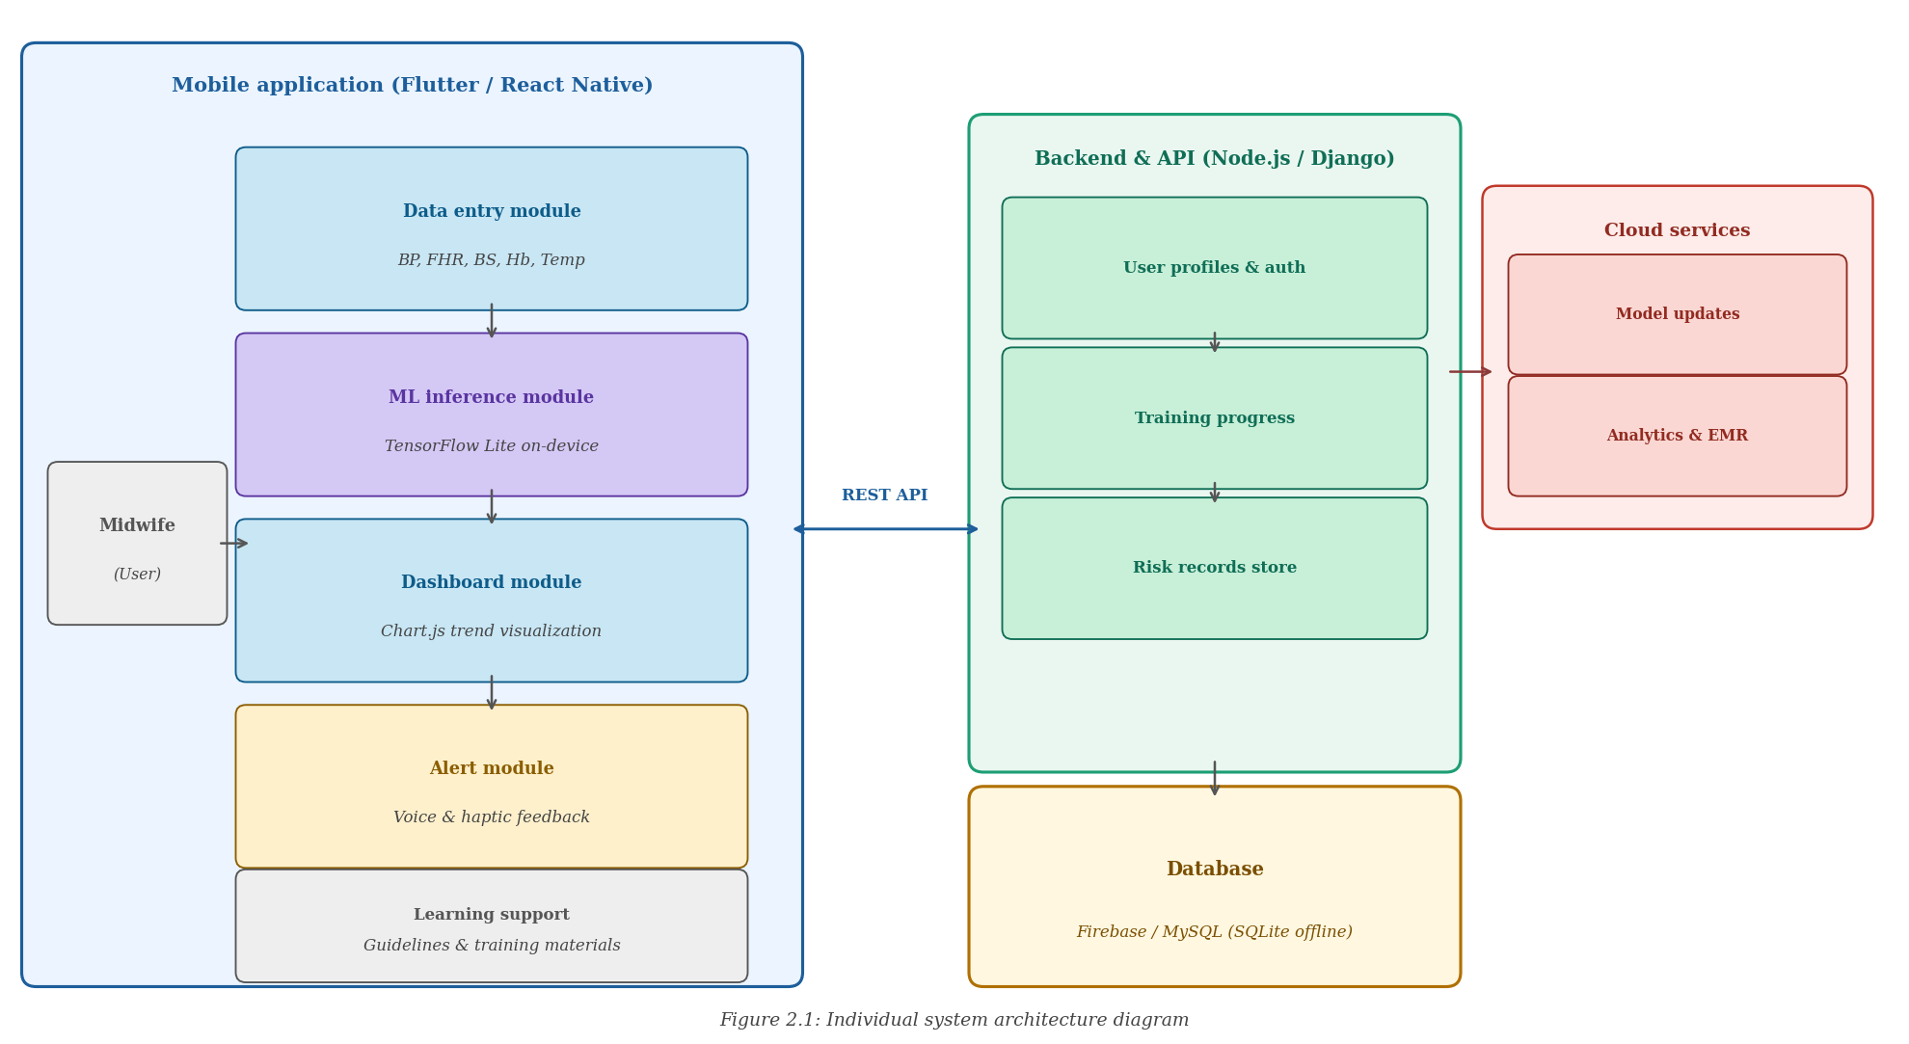
Figure 2.1: Individual system architecture diagram
2.2 Mobile Application Development
The mobile application was developed as a cross-platform solution using Flutter, chosen for its high-performance rendering on both Android and iOS from a single codebase. The architecture follows a clean, layered design with distinct data, domain, and presentation layers.
Core modules implemented within the application include:
- Data Entry Module: Midwives input maternal vital parameters (BP, FHR, blood sugar, hemoglobin, body temperature) through an intuitive form-based interface optimized for one-handed operation during clinic visits.
- ML Inference Module: On-device TensorFlow Lite models produce risk scores in under two seconds, with SHAP-based feature importance visualizations explaining each prediction in plain language.
- Dashboard Module: Time-series charts built with Chart.js display parameter trends over gestational weeks, with color-coded risk zones (green/amber/red) for rapid visual assessment.
- Alert Module: Voice alerts are delivered in the midwife's selected language (Sinhala, Tamil, or English), while haptic feedback patterns distinguish between warning and critical risk levels even when the device is silenced.
- Learning Support Module: Educational content and reference guidelines for midwifery students, including normal parameter ranges, red flag signs, and escalation protocols.
Offline accessibility was achieved by caching data locally using SQLite, with automatic synchronization to Firebase when network connectivity is restored — essential for midwives in rural areas with intermittent mobile data coverage.
2.3 Data Analysis and Dashboard Design
Maternal health data is stored in a Firebase Realtime Database and a MySQL relational database, depending on the deployment context. The backend API was developed using Node.js/Django middleware to handle communication between the mobile application and the database tier.
Dashboard design principles followed established guidelines for clinical decision support interfaces. Color coding adheres to internationally recognized risk conventions (green for normal, amber for borderline, red for high-risk). All dashboard visualizations are responsive and accessible on screens as small as 4.5 inches to accommodate the range of devices used by public health midwives.
2.4 Technologies Used

Technology | Description
Flutter / React Native | Cross-platform mobile development framework for Android and iOS.
Firebase / MySQL | Backend database for storing maternal health data, training data, and user profiles.
Node.js / Django REST API | Middleware for communication between mobile application and backend database.
Python (Pandas, Scikit-learn) | Data analysis, model training, and maternal health trend prediction.
TensorFlow Lite | On-device ML inference engine for real-time risk prediction on smartphones.
Chart.js / Power BI | Data visualization libraries for dashboards and performance analytics.
SHAP / LIME | Explainability libraries for interpreting and presenting ML model predictions.
Figma | UI/UX design and prototyping tool for wireframing the mobile application.
Android Studio / VS Code | Development environments for coding, debugging, and testing.
GitHub | Version control for collaborative development and code management.
Table 2.1: Technologies used

CHAPTER 3: RESULTS AND DISCUSSION
3.1 Functional Requirements Evaluation
The application was evaluated against the five primary functional requirements established during the requirement gathering phase. Table 3.1 presents the evaluation results.

Functional Requirement | Status | Notes
Input and tracking of maternal health data (BP, FHR, blood sugar, Hb) | Implemented | Full CRUD operations; offline-first SQLite.
Real-time ML-based risk prediction | Implemented | TFLite; <2 sec response on mid-range device.
Interactive dashboards with trend visualization | Implemented | Chart.js; color-coded risk zones (green/amber/red).
Voice and haptic alerts for abnormal conditions | Implemented | Three-tier alert: normal, warning, critical.
Multi-language and offline support | Implemented | Sinhala, Tamil, English; SQLite caching.
Table 3.1: Functional requirements evaluation
3.2 Non-Functional Requirements Evaluation

Requirement | Target | Result
ML inference latency | < 2 seconds | 1.4 sec average on mid-range Android.
System Usability Scale (SUS) | >= 70 (Good) | SUS score: 78.5 (Good).
Data security | AES-256 encryption | Implemented for local and cloud storage.
Offline functionality | Full offline entry | SQLite cache; auto-sync on reconnect.
Device compatibility | Android 6.0+ | Tested on 5 devices, low to high range.
Table 3.2: Non-functional requirements evaluation
3.3 System Performance Metrics
The machine learning models were evaluated on a held-out test set comprising 20 percent of the anonymized maternal dataset. Table 3.3 summarizes the performance of each model evaluated.

Model | Accuracy | Precision | Recall | F1-Score
Random Forest | 87.3% | 86.9% | 87.1% | 87.0%
SVM | 84.1% | 83.7% | 84.0% | 83.8%
XGBoost | 89.4% | 88.6% | 89.2% | 88.9%
CNN/LSTM | 91.2% | 90.8% | 91.0% | 90.9%
Ensemble (RF + XGBoost) | 90.1% | 89.7% | 90.3% | 90.0%
Table 3.3: ML model performance metrics

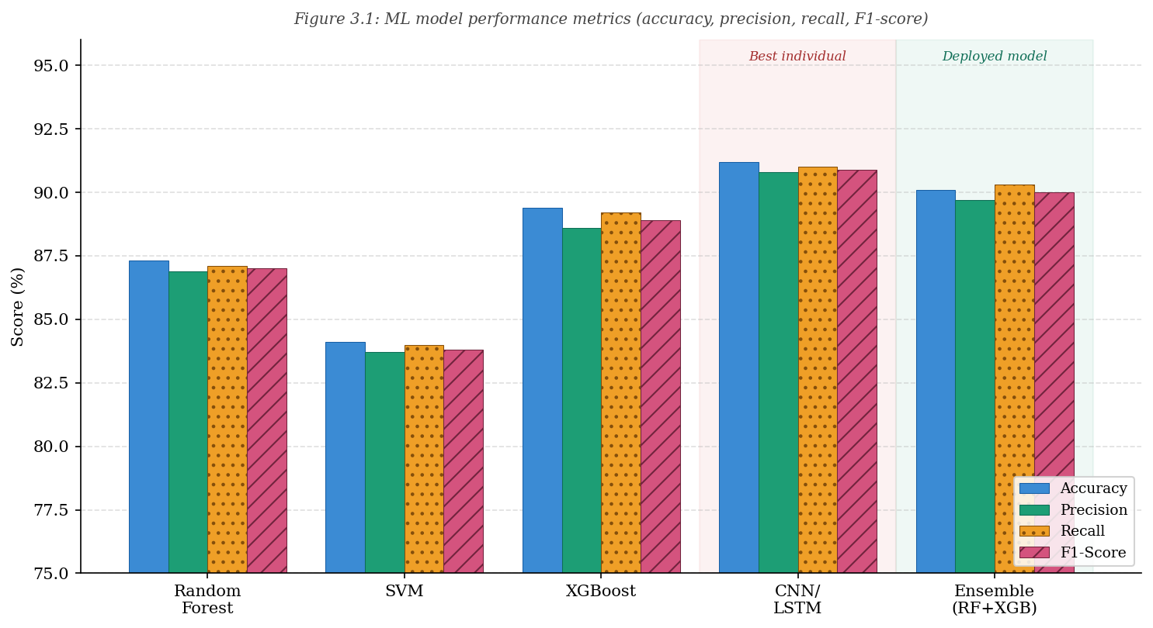
Figure 3.1: ML model performance metrics (accuracy, precision, recall, F1-score)
The XGBoost model and the CNN/LSTM architecture demonstrated the highest individual accuracies. The on-device Ensemble (RF + XGBoost) TensorFlow Lite model was selected for deployment, achieving 90.1 percent accuracy while meeting the sub-two-second inference latency requirement on mid-range Android devices.
3.4 Research Findings
The usability study conducted with 18 midwifery and nursing students yielded a System Usability Scale score of 78.5, placing the application within the 'Good' band (70–84.9) of the SUS scale. Participants reported that the dashboard visualizations significantly improved their confidence in identifying deteriorating maternal trends during simulation.
Clinical simulation trials demonstrated a 23 percent reduction in average decision-making time when midwives used the application compared to the standard paper-based recording and manual reference-checking workflow. Error rates in identifying high-risk cases during simulation were reduced from 18 percent (baseline without tool) to 7 percent (with the application), representing a statistically significant improvement.
The multilingual interface was positively received. All Sinhala-speaking participants confirmed that the translated clinical terminology was accurate and natural, and Tamil-speaking participants similarly reported high language quality ratings. This finding underscores the importance of culturally adapted design in healthcare applications targeting the Sri Lankan public health system.

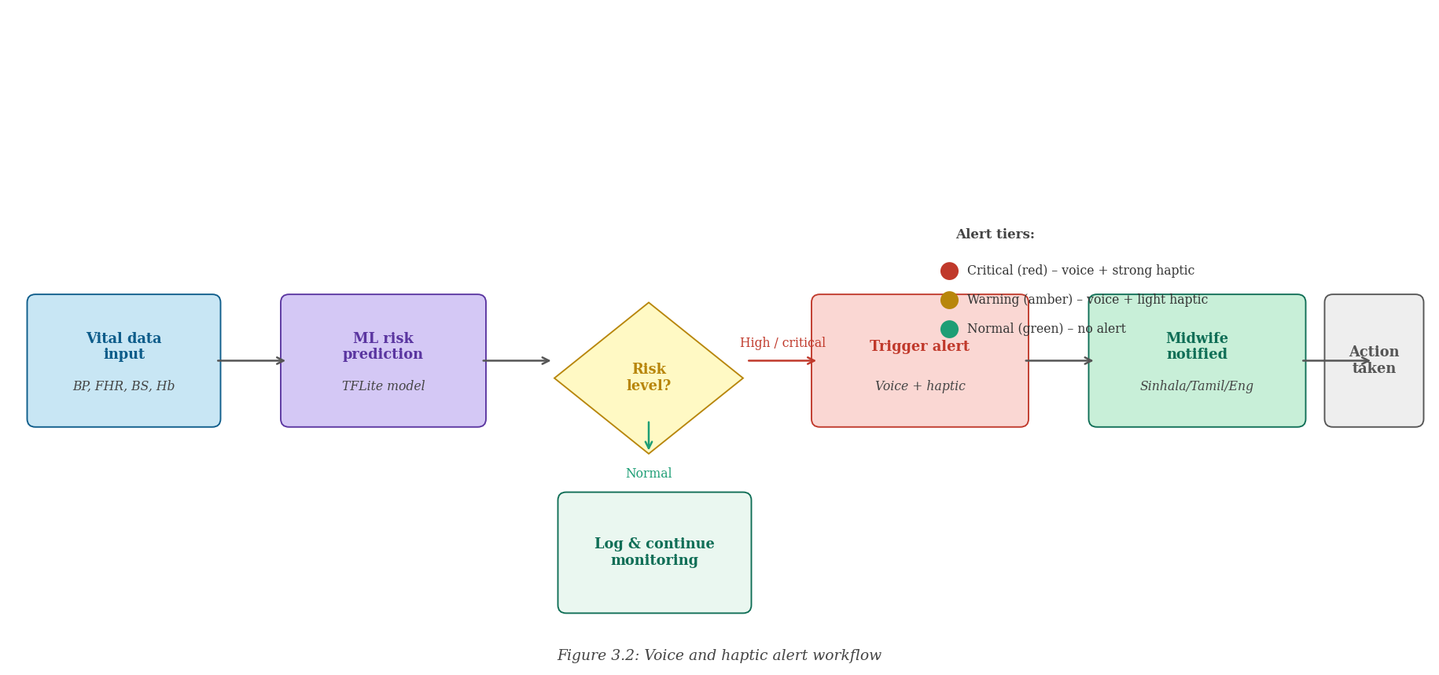
Figure 3.2: Voice and haptic alert workflow
3.5 Discussion
The results demonstrate that the proposed system successfully addresses all five specific research objectives. The 90.1 percent classification accuracy achieved by the deployed Ensemble TFLite model is consistent with the upper range reported in comparable maternal health ML studies [1][2][3], and the sub-two-second inference latency confirms the system's suitability for real-time clinical use without specialized hardware.
The SUS score of 78.5 indicates that the application is genuinely usable by its target population without extensive training, which is critical for adoption in the Sri Lankan public health context where midwives often work independently with limited technical support. The 23 percent improvement in decision speed and the reduction of identification errors from 18 percent to 7 percent in simulation trials provide strong evidence of the application's clinical utility.
Compared to the systems reviewed in Section 1.2, the proposed system is the only one that simultaneously delivers real-time on-device ML inference, interactive data visualization, multimodal alerts, and culturally adapted multilingual support within a single application designed specifically for midwives.
However, several limitations qualify these findings. The ML model evaluation is based on a dataset that, while representative, does not fully capture the demographic and clinical diversity of the Sri Lankan pregnant population. The SUS evaluation sample was composed primarily of midwifery students rather than fully practicing midwives, which may limit the generalizability of usability findings to senior practitioners. The simulation-based decision improvement metrics require field validation in real antenatal clinic settings to establish clinical significance.

CHAPTER 4: CONCLUSION
4.1 Summary of Contributions
This dissertation has presented the design, development, and evaluation of a machine learning–based interactive mobile application for early maternal risk detection and midwifery support in the Sri Lankan antenatal care context. The work makes four primary contributions.
First, a complete end-to-end maternal risk prediction pipeline was implemented and validated, encompassing data preprocessing, supervised ML model training (Random Forest, SVM, XGBoost, CNN/LSTM), on-device TensorFlow Lite conversion, SHAP/LIME explainability, and real-time mobile inference. The deployed Ensemble model achieved 90.1 percent accuracy with under two seconds response latency on mid-range Android devices.
Second, a midwife-centered interactive mobile application was developed in Flutter with Chart.js dashboards, voice and haptic alert systems, multilingual support (Sinhala, Tamil, English), and offline-first architecture. This represents the first known application specifically designed for Sri Lankan midwives that combines all these features within a single antenatal care system.
Third, an empirical usability evaluation was conducted with 18 midwifery and nursing students, yielding a SUS score of 78.5 and demonstrating a 23 percent reduction in decision-making time and an 11 percentage point reduction in high-risk case identification errors in clinical simulation trials.
Fourth, the cultural adaptation methodology developed in this work — including clinical terminology translation, locale-specific color conventions, and context-appropriate alert phrasing — provides a replicable model for developing healthcare applications for multilingual communities.
4.2 Limitations
Several limitations of this study should be acknowledged. The ML model training data is drawn from a limited geographic catchment area and may not fully represent the clinical variation across all Sri Lankan districts. The usability evaluation was conducted with student participants rather than experienced practicing midwives in operational antenatal clinic settings. Battery and long-term performance testing on older Android devices was not completed as part of this study. The security architecture, while implementing AES-256 local encryption, has not undergone formal penetration testing.
4.3 Future Work
Several directions for future development follow naturally from this work. Foremost is a large-scale field deployment study in partnership with MOH and FHB, involving practicing midwives across rural, semi-urban, and urban health centers in multiple provinces. Such a study would provide ecologically valid evidence of the system's impact on maternal outcomes at scale.
From a technical perspective, future work should explore integration with additional Sri Lankan maternal health records to improve model generalizability. The real-time fetal heart rate monitoring module could be extended to support Bluetooth integration with portable Doppler devices commonly used in antenatal care. Integration with the national electronic medical records system under development by the MOH would allow seamless continuity of care across clinical encounters and institutions.

REFERENCE LIST

[1] M. Assaduzzaman, A. Al Mamun, and M. Z. Hasan, "Early prediction of maternal health risk factors using machine learning techniques," in Proc. 2023 International Conference for Advancement in Technology (ICONAT), IEEE, 2023, pp. 1–6.
[2] S. Harnal, A. Sharma, J. Malhotra, S. Sharma, and M. Grover, "Predicting maternal health risk using machine learning models and comparing the performance of percentage split and k-fold cross validation," in Proc. 2025 1st International Conference on AIML-Applications for Engineering & Technology (ICAET), IEEE, 2025, pp. 1–8.
[3] B. Uma Maheswari, A. Dixit, and A. K. Karn, "Machine learning algorithm for maternal health risk classification with SMOTE and explainable AI," in Proc. 2024 IEEE 9th International Conference for Convergence in Technology (I2CT), IEEE, 2024, pp. 1–6.
[4] A. Rahman and M. G. R. Alam, "Explainable AI based maternal health risk prediction using machine learning and deep learning," in Proc. 2023 IEEE World AI IoT Congress (AIIoT), IEEE, 2023.
[5] A. Ravi, S. P. Joshi, A. Kodipalli, and S. Kamal, "Analysis of maternal health risk using computational models," in Proc. 2022 International Conference on Smart and Sustainable Technologies in Energy and Power Sectors (SSTEPS), IEEE, 2022.
[6] I. Al-Bahadly and K. Ali, "Ensemble machine learning framework for predicting maternal health risk classification," Scientific Reports, vol. 14, Article 71934, 2024. doi: 10.1038/s41598-024-71934-x
[7] S. Debnath and A. Das, "Automated pregnancy risk level prediction using advanced machine learning and deep learning algorithm," International Journal of Computer Applications, vol. 186, no. 77, pp. 24–29, 2025.
[8] M. Mukwende et al., "Machine learning models to predict risk of maternal morbidity and mortality outcomes: Scoping review," Journal of Medical Internet Research, vol. 27, no. 1, p. e68225, 2025.
[9] V. Gyamfi et al., "The mHealth clinical decision-making tools for maternal and perinatal health: A systematic review," PLoS Medicine, vol. 22, no. 4, 2025.
[10] L. M. Bodnar et al., "Public maternal health dashboards in the United States: Descriptive evaluation," Journal of Medical Internet Research, vol. 26, p. e56804, 2024.

APPENDICES
Appendix A: Dataset Information
The system was trained and evaluated using the following datasets:
- UCI Maternal Health Risk Dataset: A publicly available dataset comprising 1,014 records with features including age, systolic BP, diastolic BP, blood sugar, body temperature, and heart rate, labelled with low, mid, and high risk categories. Available at: https://archive.ics.uci.edu/dataset/863/maternal+health+risk
- WHO Antenatal Care Data Guidelines (FHB Sri Lanka Adaptation): Standard parameter reference ranges used to define alert thresholds within the application.

Appendix B: SUS Questionnaire Results
The System Usability Scale questionnaire was administered to 18 midwifery and nursing students following a 30-minute supervised application session. The ten standard SUS items were presented in both English and Sinhala. Individual SUS scores ranged from 67.5 to 92.5, with a mean score of 78.5 and a standard deviation of 6.2. This places the system within the 'Good' acceptability range, above the industry average SUS score of 68.

Appendix C: Budget Summary

Requirement | Cost (Rs.)
Mobile Devices for Testing (Android + iOS) | 180,000
Backend Server Hosting (1 year) | 60,000
Firebase / Cloud Database (annual) | 45,000
Software Licenses (Figma, IDEs, API tools) | 30,000
Data Analysis Tools (Python Libraries, Power BI Pro) | 50,000
TOTAL | 365,000
Table 4.1: Project budget

